RIPHAH INTERNATIONAL UNIVERSITY ISLAMABD
LAB 3
SUBMITTED TO : Mam Ayesha
Submitted by: Fatima nazir 45317

TASK:1
#include<iostream>
using namespace std;

int main(){

string input;
cout<<"Enter the statement:";
getline(cin,input);
string token="";
for(int i=0;i<input.length();i++){
if(input[i]!=' '){
token+=input[i];
} else{

cout<<"TOKEN:"<<token<<endl;
token=' ';

}
}
cout<<"TOKEN:"<<token<<endl;

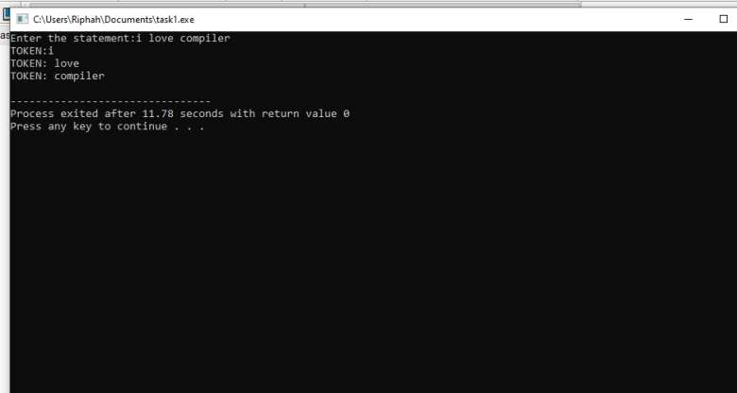

TASK:02
#include<iostream>
using namespace std;

int main(){
string input;

cout<<"Enter the Statement: ";
getline(cin,input);
string token="";
for(int i=0;i<input.length();i++){
if(input[i]!=' '){

token+=input[i];
}
else{
if(token=="int"||token=="float")
cout<<token<<":KEYWORD\n";
else if(token=="+"||token=="=")
cout<<token<<":OPERATOR\n";
else if(token[0]>'0'&&token[0]<='9')
cout<<token<<":NUMBER\n";
else
cout<<token<<":INDENTIFIER\n";
token="";

}}
if(token=="int"||token=="float")
cout<<token<<":KEYWORD\n";
else if(token=="+"||token=="=")
cout<<token<<":OPERATOR\n";
else if(token[0]>'0'&&token[0]<='9')
cout<<token<<":NUMBER\n";
else
cout<<token<<":INDENTIFIER\n";

}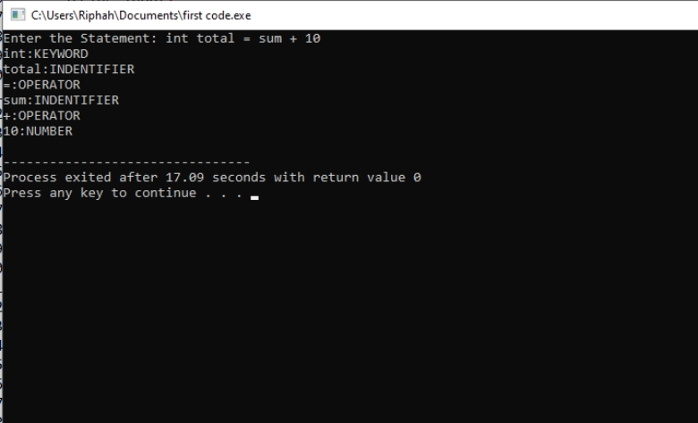

TASK:03
#include <iostream>
using namespace std;
int main(){
string input;
cout<<"Enter statement: ";
getline(cin,input);
string token="";
for(int i=0;i<input.length();i++){
if(input[i]!=' ')
token+=input[i];
else{
if(token=="int"||token=="float"||token=="double"||token=="char")
cout<<token<<" : KEYWORD\n";
else if(token=="+"||token=="-"||token=="*"||token=="/"||token=="=")
cout<<token<<" : OPERATOR\n";
else if(token[0]>'0'&&token[0]<='9')
cout<<token<<" : NUMBER\n";
else if(token=="if"||token=="else if"||token=="else")
cout<<token<<" :STATEMENT\n";
else if(token=="do"||token=="while"||token=="for")
cout<<token<<" :LOOP\n";
else
cout<<token<<" :IDENTIFIER\n";
token="";
}}
if(token=="int"||token=="float")
cout<<token<<" : KEYWORD\n";
else if(token=="+"||token=="-")
cout<<token<<" : OPERATOR\n";
else if(token[0]>'0'&&token[0]<='9')
cout<<token<<" : NUMBER\n";
else if(token=="if"||token=="else if"||token=="else")
cout<<token<<" : STATEMENT\n";
else if(token=="do"||token=="while"||token=="for")
cout<<token<<" :LOOP\n";
else
cout<<token<<" :IDENTIFIER\n";
}